Stats Video Lectures – Conditional Probability

Week 2, Video 5

Info Source : Adolescents’ Understanding of Social Class

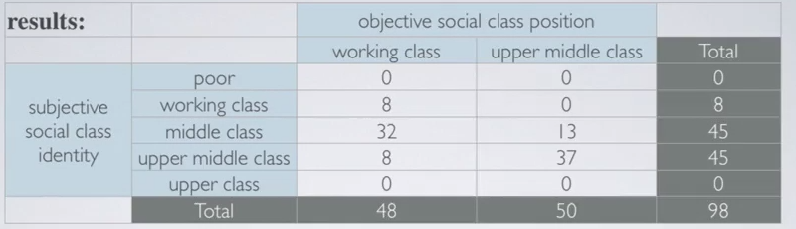

1. Marginal Probability
   1. the probabilities around the margins of a distribution table

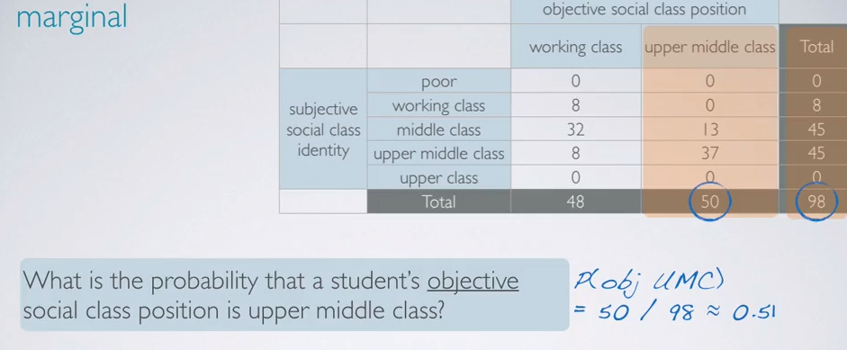

1. Joint Probability
   1. the probabilities found at the intersection of interest in the distribution table
   2. joint probabilities always have the term AND in it

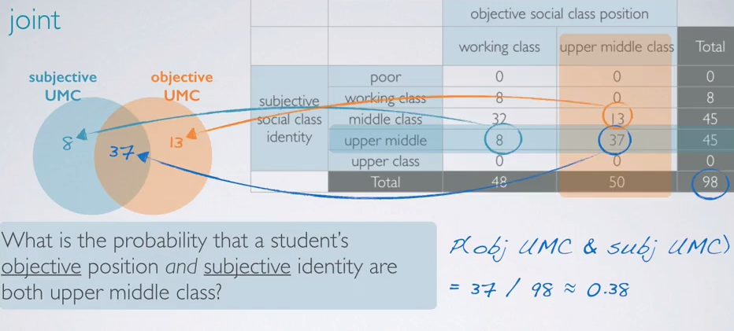

1. Conditional Probability
   1. the probability found at the intersection of A given B, disregarding the total number of subjects

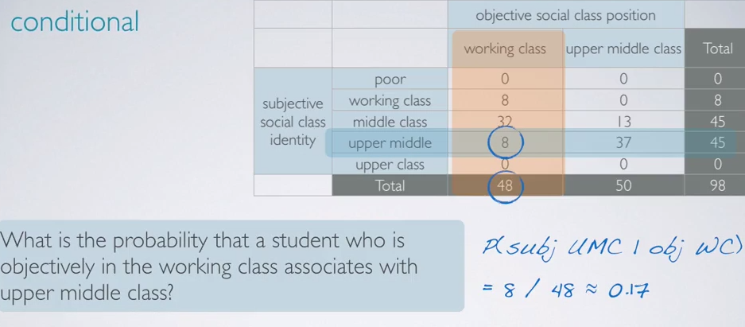

1. Bayes’ Theorem of conditional probabilities

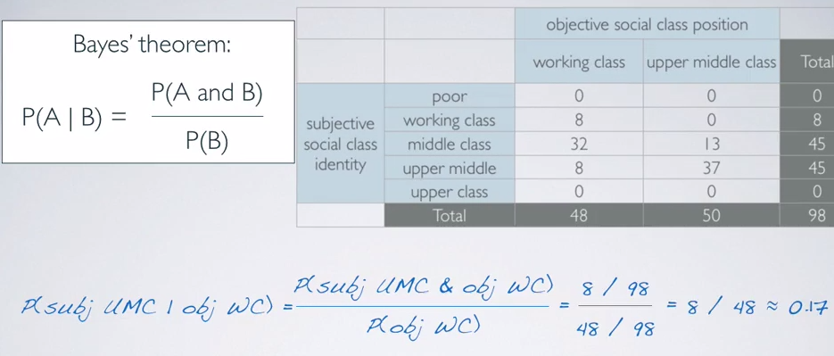

1. General Product Rule
   1. P(A and B) = P(A|B) \* P(B)
   2. does not matter if the probs are dependent or not
   3. if P(A|B) = P(A), then events a and B are independent
      1. So, P(A and B) = P(A) \* P(B) in this case
      2. Concepturally, if B doesn’t tell us anything about A, they’re independent, and P(A|B) = P(A)
   4. 